Create one VPC, with 1 public subnet and 1 private subnet

I will be creating a new vpc with one public subnte and private
For this I will be creating new 2 subnets one with internetgateway acces and other with no access

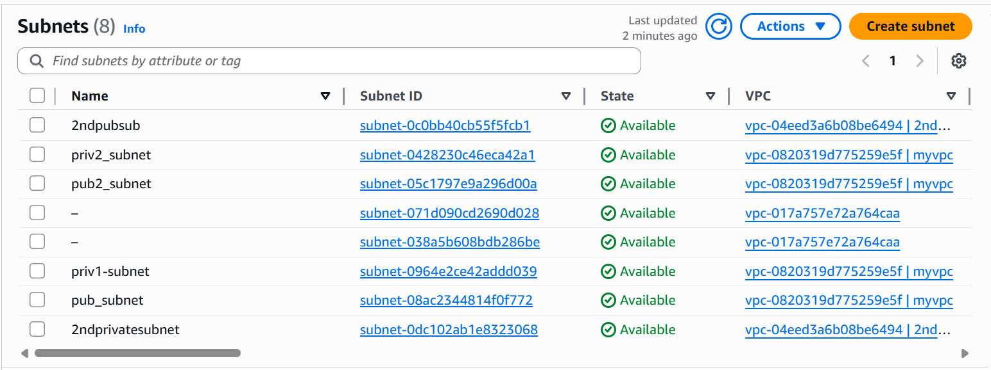
I have created a new routes for new subnets and attached it to the respective route tables
And added internet gateway access extra to public subnet because it should have internet access
And not added to private subnet be=cause I don’t want to expose to internet

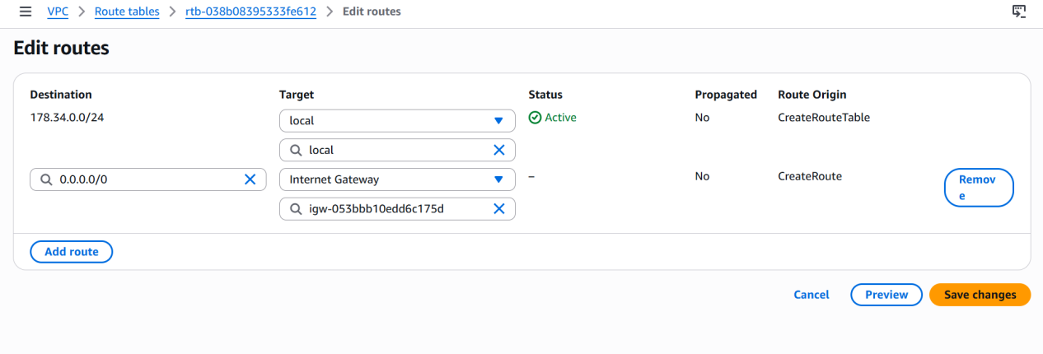
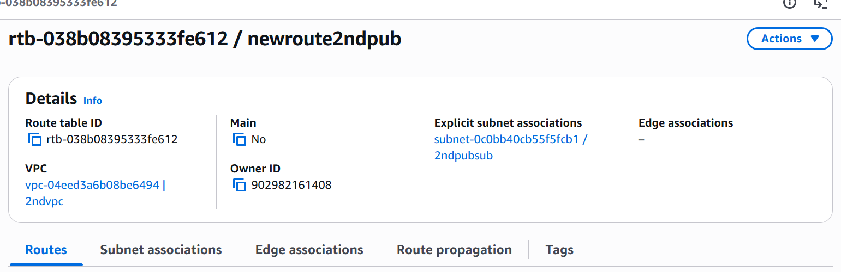

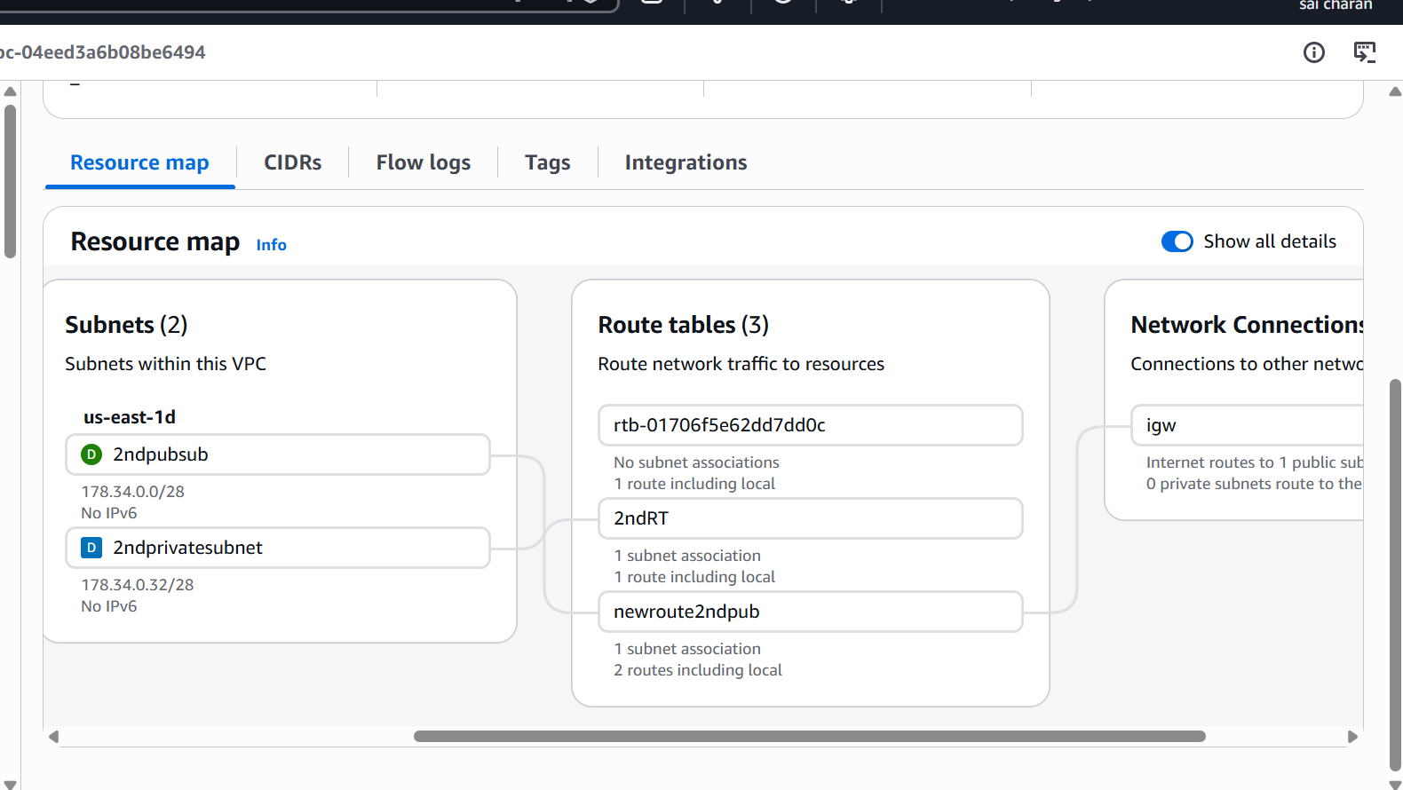

Here I have created 1 public subnet and 1 private subnet for my vpc]

Enable VPC peering for cross-region

Here vpc peering is used to connect blw two or more vpc from same,different region,different accounts

And vpc-peering is bidirectional communication

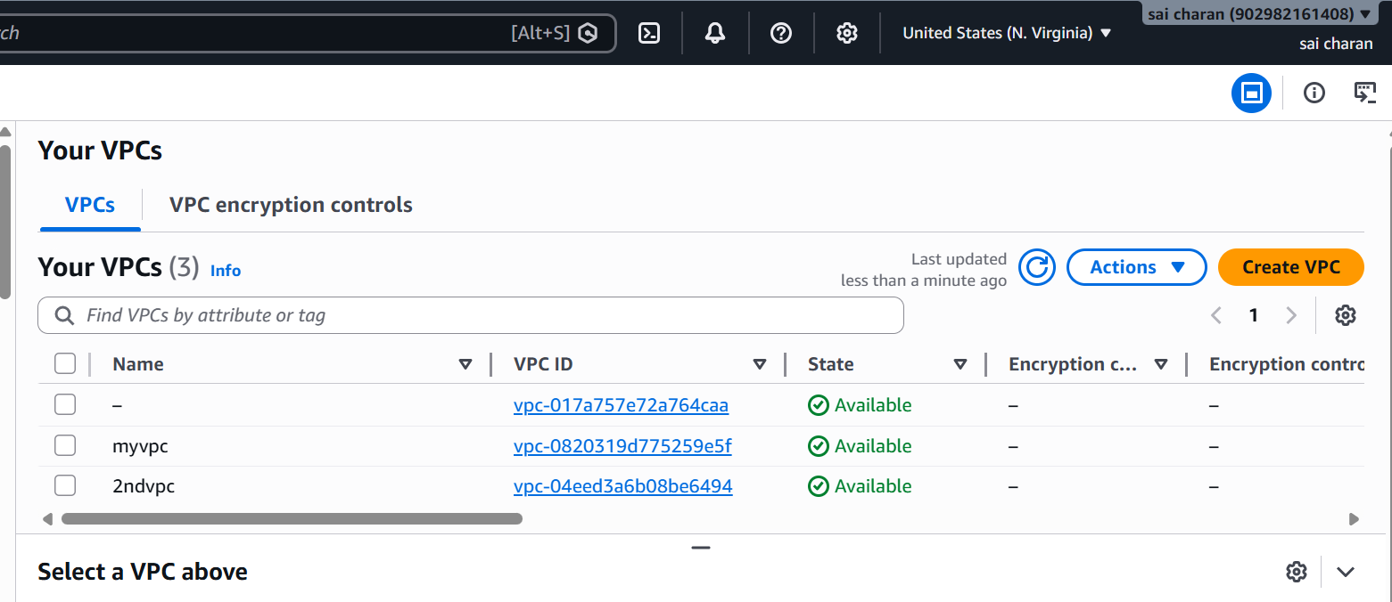
Here I have my vpc in N.VIRGINIA region and I will be creating a new vpc in ohio and launching a new instance

I can see the other region instance connectivity by ping their public address
But if I use ec2 private ip from ohio region instance then the connection wont be established because private ip wont be connected but public ip can be connected because it is open

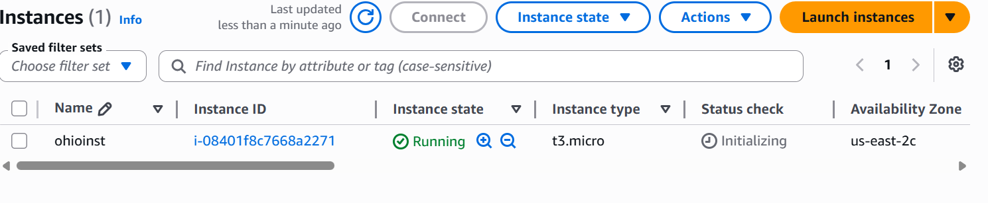
I have created new inst in ohio
Now I will vpc-peering from n.virginia instance to ohioinst instance
To connect blw to vpc’s
To connect vpc-peering create new vpc peering
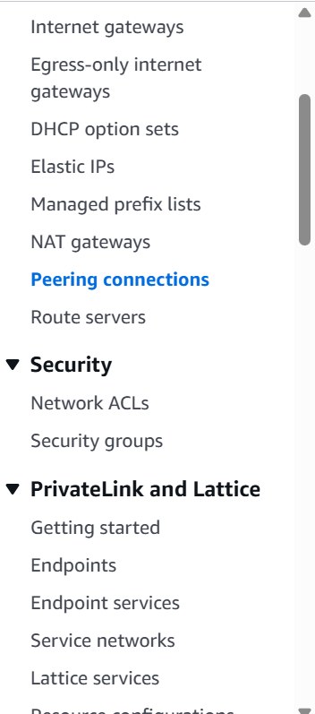
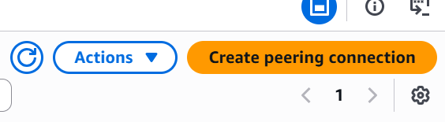

Now I have to give vpc of the current region for which peering connection will establish
And I have to give the destination vpc
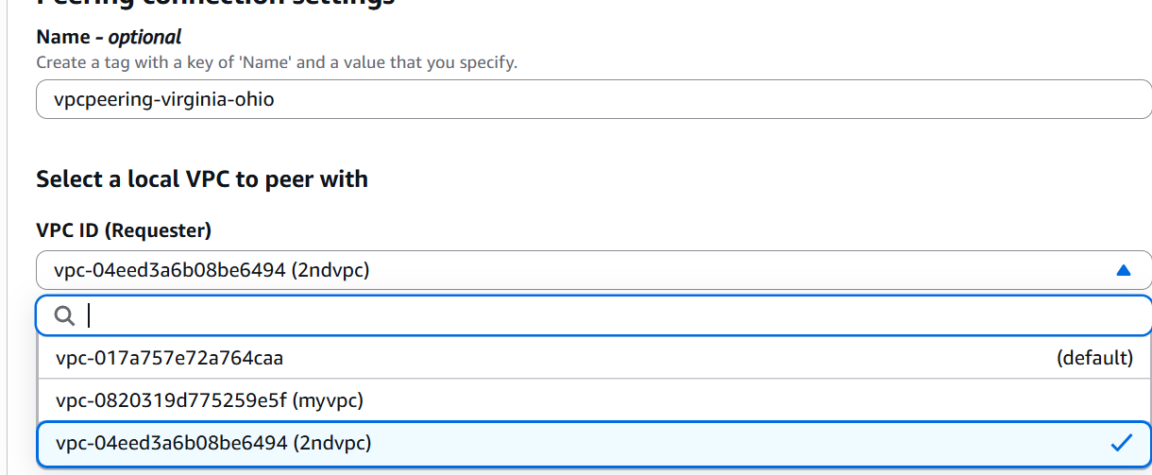

Here I need to give ogio region vpc to connect

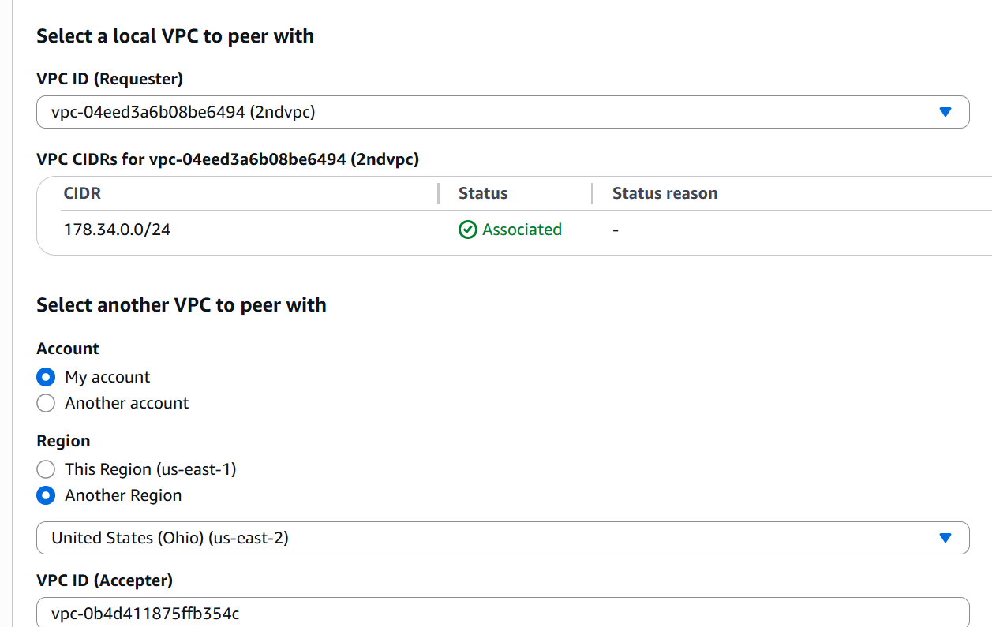

Now it will send a peering connection to ohio region

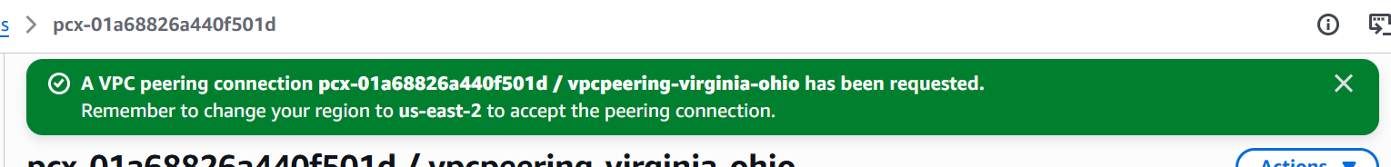

We can see the request from N.virginia region

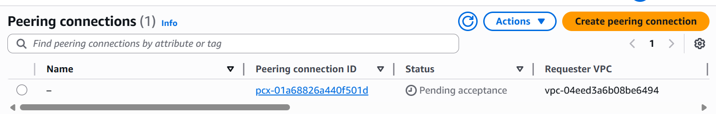

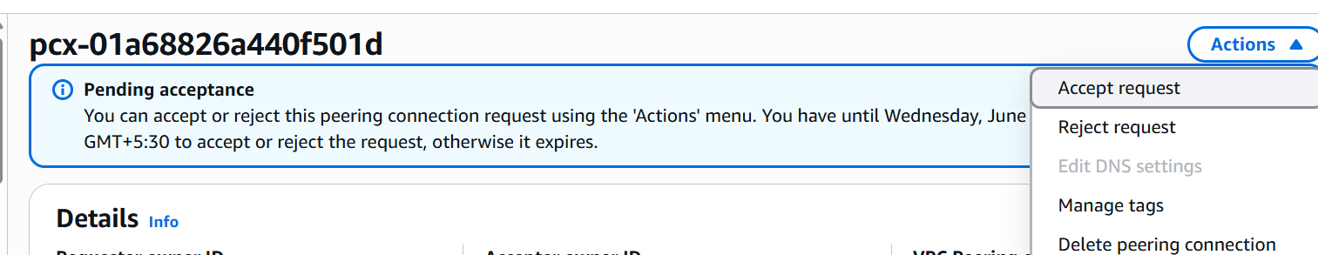

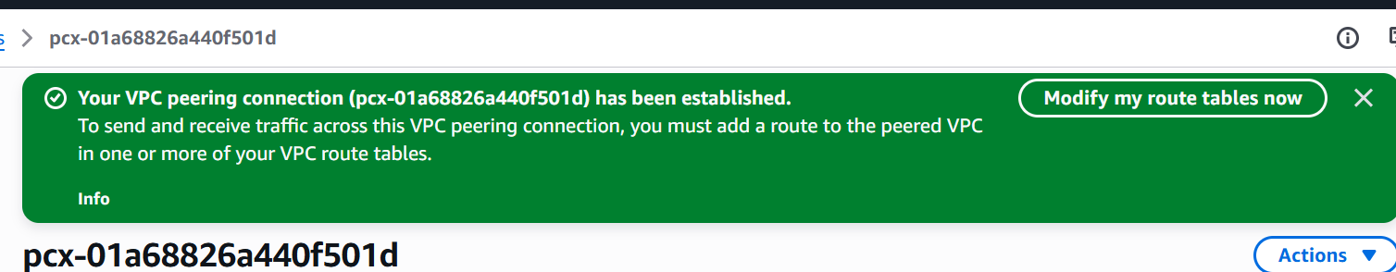

We have to give their ipvr CIDR in both region route table ROUTES

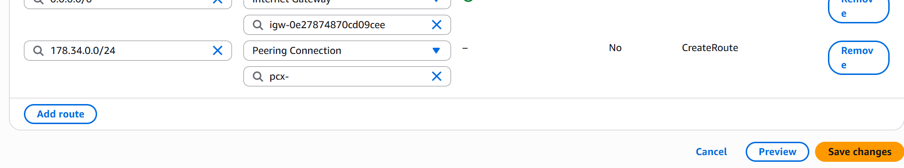
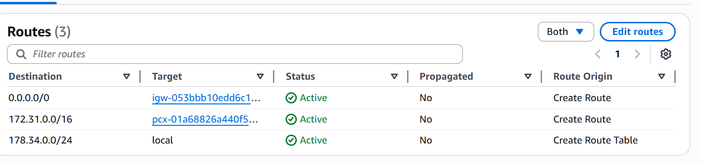

Enable VPC peering for cross-account

VPC peering is a bidirectional


Here I have my vpc in N.VIRGINIA region and another user in another account created new vpc in ohio and launching a new instance

I can see the other region instance connectivity by ping their public address
But if I use ec2 private ip from ohio region instance then the connection wont be established because private ip wont be connected but public ip can be connected because it is open




Now I have to give vpc of the current region for which peering connection will establish
And I have to give the destination vpc


Here I need to give another account vpc to connect



Now it will send a peering connection toanother aws account user



We can see the request from N.virginia region in other account







We have to give their ipvr CIDR in both region route table ROUTES




By this a vpc peering request is paired for both accounts

Set up a VPC Transit Gateway

Vpc transit gateway will help us to connect blw multiple vpc on cloud
It will create a hub and spoke design to connect multiple vpc

Vpc transit gateway is chargable

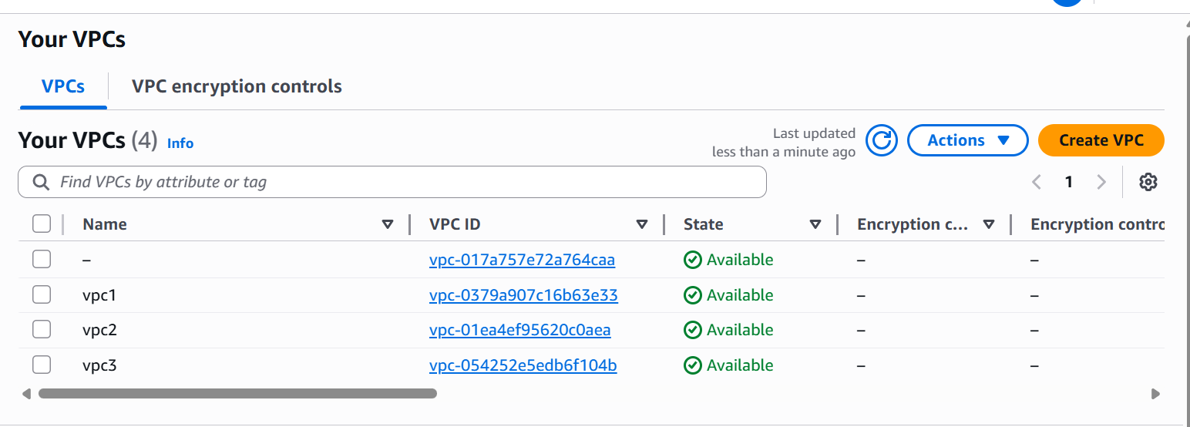

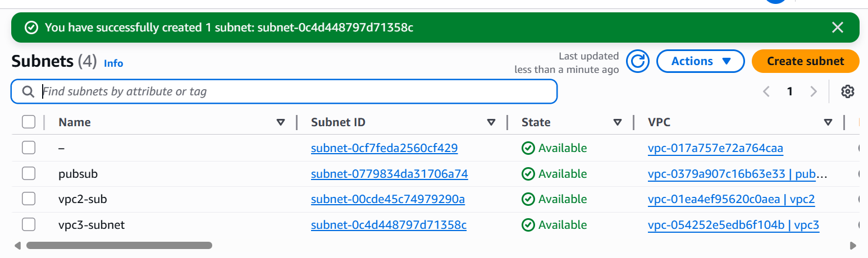

1 subnet for every 1 vpc

Now I will be creating a transit gateway
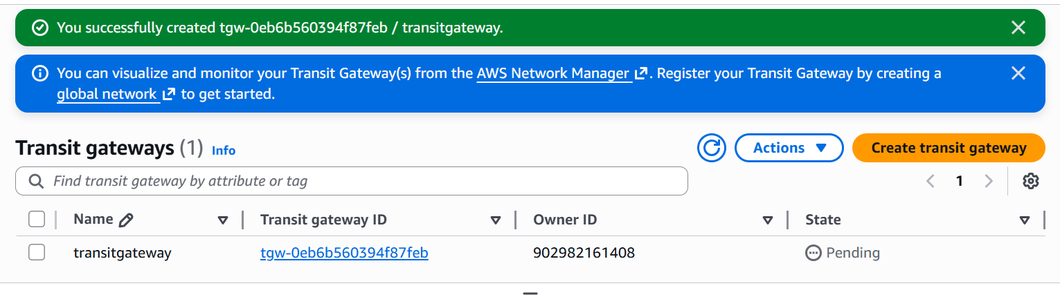

Next create tansit gateway attachments for every vpc
I am creating 3 attachements for 3 vpc
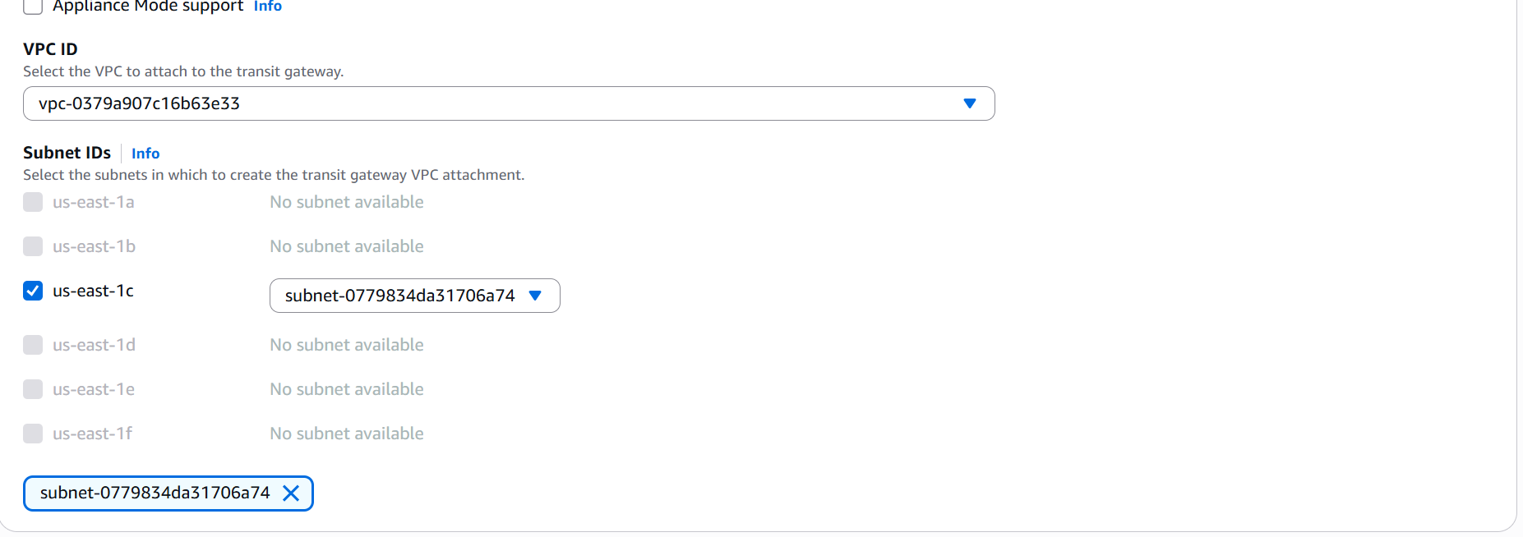

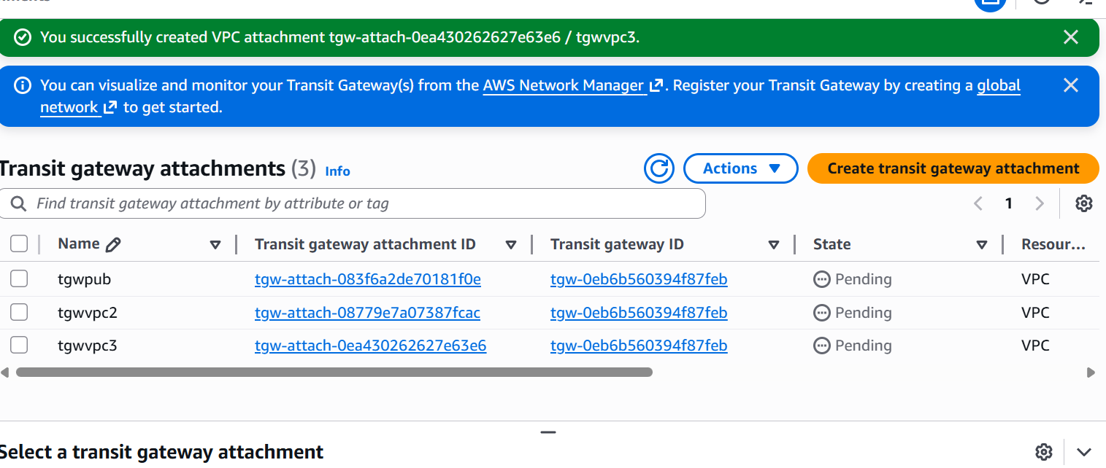

Now head back to vpc route table
And allow other vpc ips in route table for every vpc route
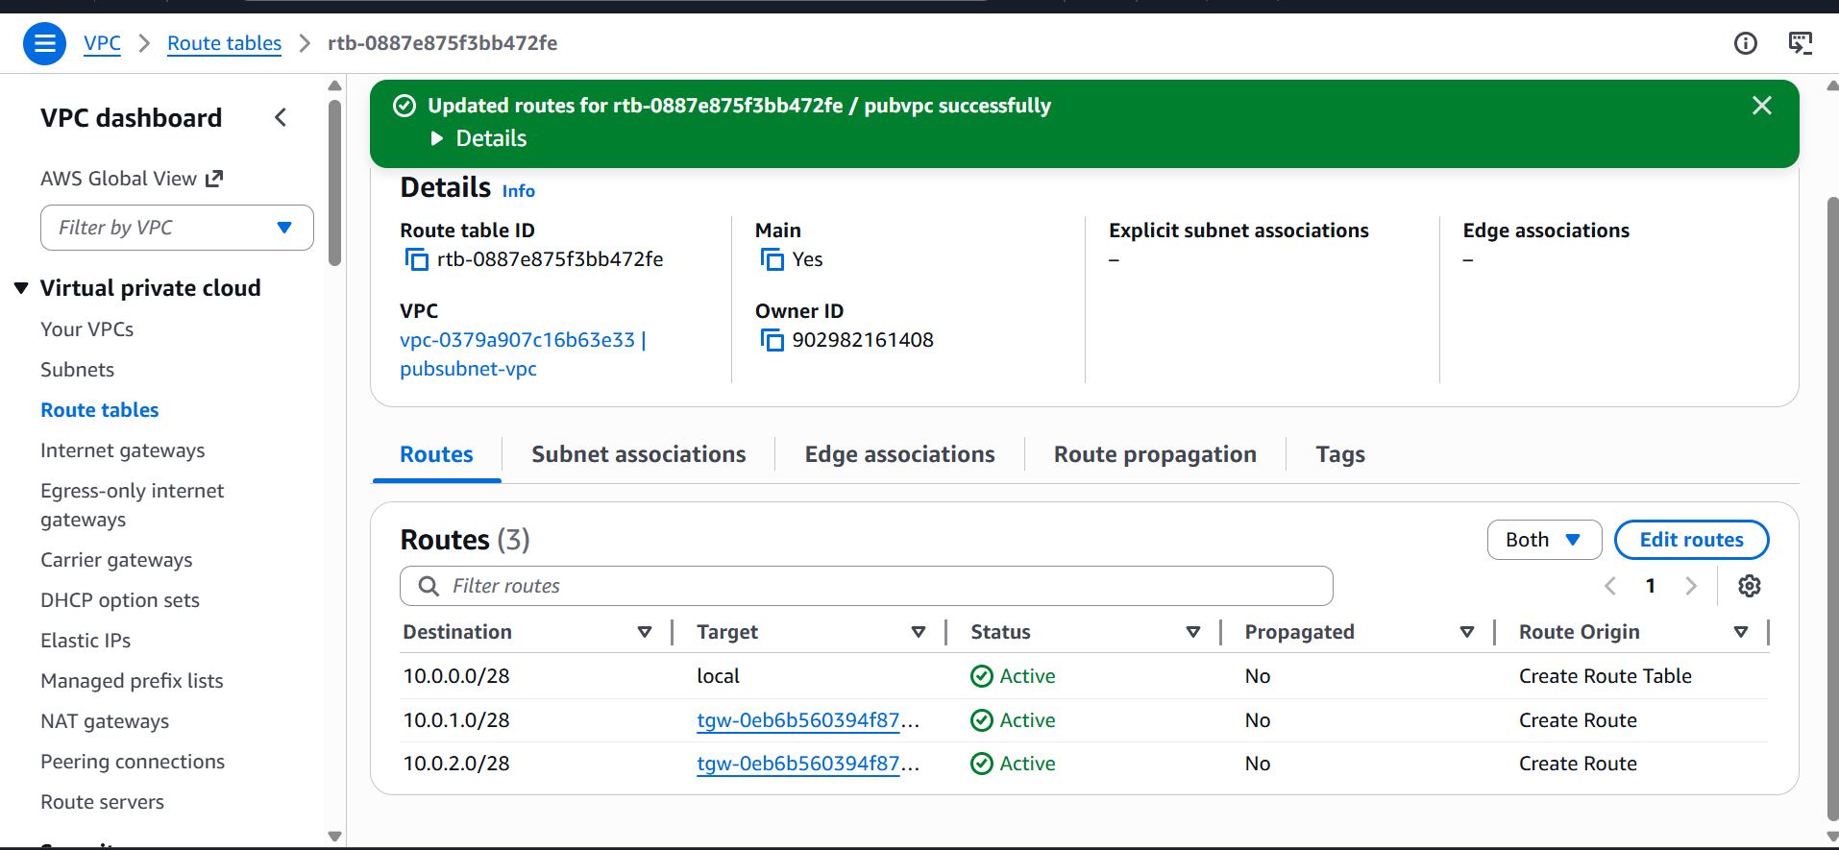

Do this for every vpc we want to connect to transit gateway

I will be creating a new instance for every 1 vpc
Total 3 instances and 1 is public and 2 private with different vpc for every instance
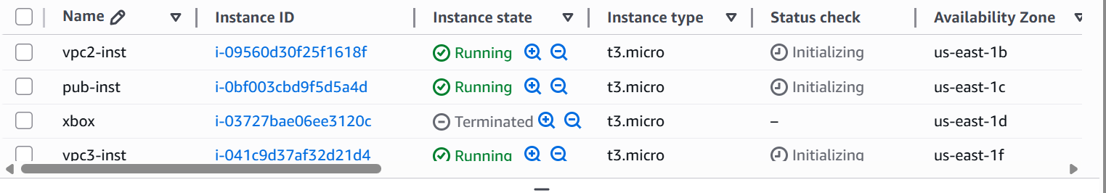

Now the transit gateway was successful blt 3 vpcs and can ping with private ip of private subnets

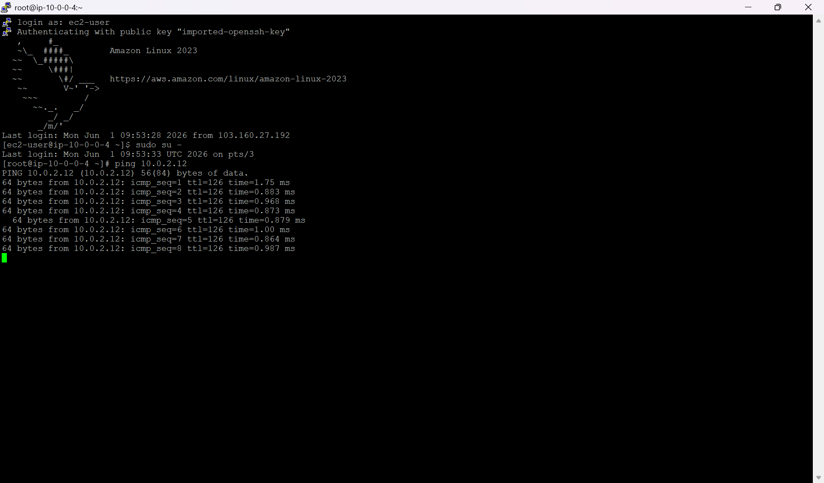

Set up a VPC Endpoint

If a private subnet want to connect to a aws service like s3
Then private subnet need internet access to connect to s3
Here endpoint solves this issue as s3 is out of vpc and different service in aws to connect in a secured way we will be allocating endpoint to s3 then to private subnet

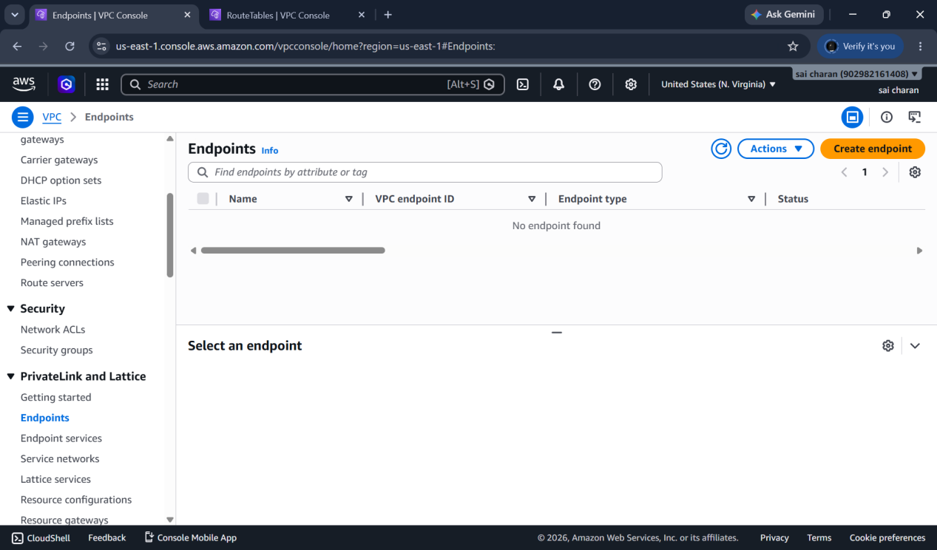

Here we can also give endpoints cross region
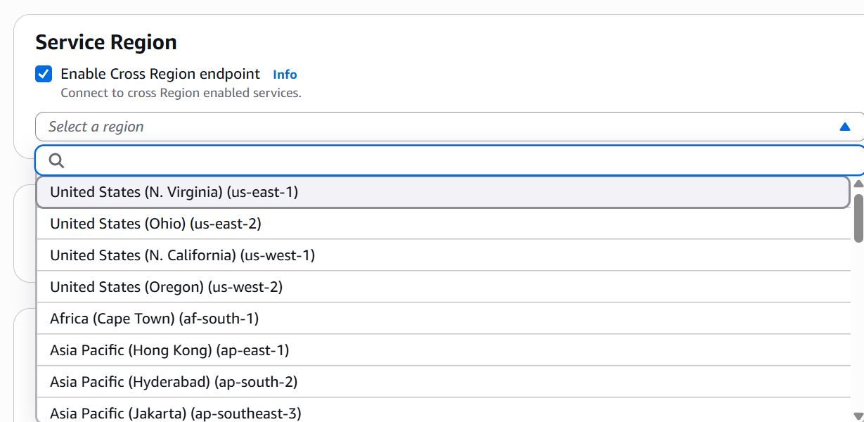

Then check for s3 in services

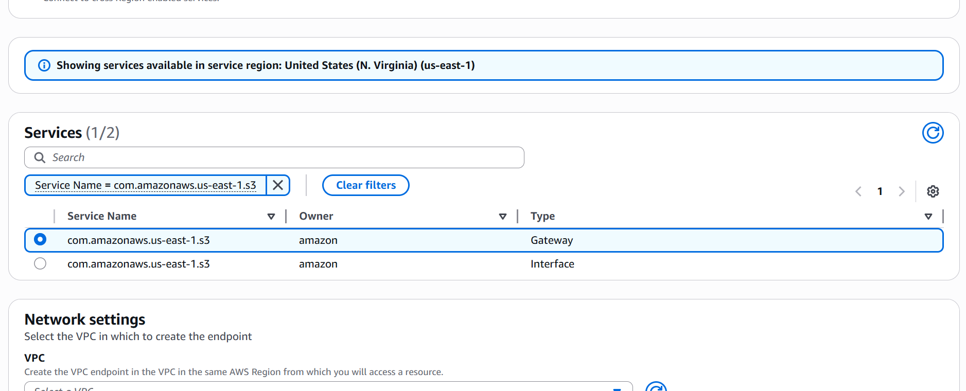

Select gateway for s3
And select for which vpc you want to create the endpoint
